Tutorial 1: WRES1201 Computer System Architecture

- Explain the computer component?
- Explain the issues in computer architecture?
- What is a machine cycle?
- What are common components inside the microprocessor? And then discuss the purpose of each component.
- What are differences between Computer Architecture and Computer Organization?
- Explain what is
  - Instruction Set Architecture (ISA)
  - Instruction Set
  - Firmware
  - Compiler
  - Source Code

- Give the specification of the current Intel Processors.

- Describe the level of representation below:

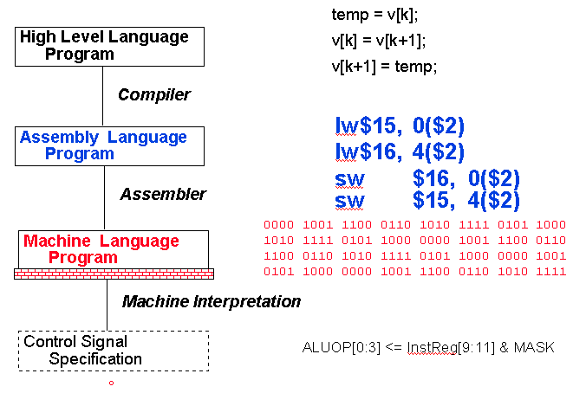

- What are the main function of the following terms:
  - Bus System
  - FPU
  - DDR
  - Plug and Play technology
  - Port, jack and connector

- Moore’s Law, what is the current status? Discuss the problem about heat and computer speed.

- What is the purpose of
  - Bits and Bytes
  - Digital Logic
  - Processor & Instruction Set
  - Assembly Language Programming
  - Interrupt, Traps and IO
  - HL Programming

